Installation and User Manual

Tested on Google Chrome 29 – 33, Mozilla Firefox 27**.**

**Optimised for Google Chrome 32+**

# Installation

1. Copy site folder to the document root of your web server set up
2. Open up a web browser and navigate to the URL of the folder.
   1. If this is the first time you have run the shop then you should be presented with an “Initial Setup” page
3. Follow the instructions to give your shop a name, theme, and enter in the correct credentials for your MySql server.
4. Click “Submit” and your database will be created or will connect to an existing one if you specify its name.
5. On the next page you will be given the option to add sample data; check the box to add sample data and click “Submit.”

# Content Management

In order to access the content management pages of your shop use the link in the bottom right hand corner of each page.

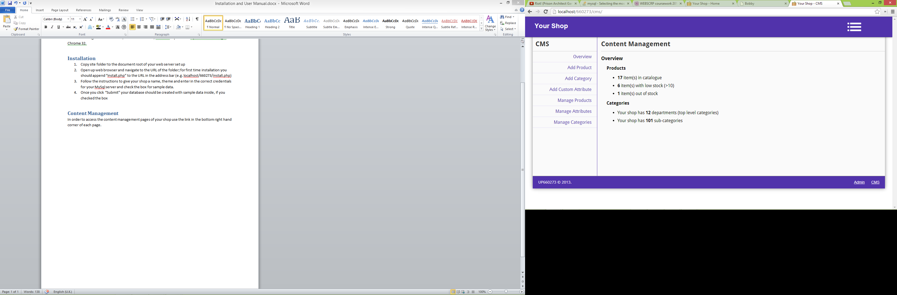You will be presented with an initial overview of your products and categories:

From this section of the site you can add products, categories and custom attributes by following the relevant links on the left hand side. These links can also be accessed through using the navigation drop menu in the top right corner of the page. These are both indicated by red boxes above.

# Adding Categories

1. Using either navigation available(left or top right) follow the link to “Add Category”
2. Give the category a name and choose its parent category by checking the radio button next to it
   1. Choose “Root” if it is a top-level category/department
   2. Click the folder icon to expand a category and view sub-categories, if present.
3. Click “Save” when you are done.

# Adding Products

1. Using either navigation available follow the link to “Add Product”
2. Give the product a name and detailed description (you can add product attributes later, for example: weight, dimensions, battery life, screen size, colour, etc…).
3. Enter in the price the product is to be sold for and the quantity in whole units available in stock
4. You *must* upload at least one primary image, do so by either finding the image you wish to add in your OS’s file explorer and dragging it over the “Choose File” button, or clicking the button and finding the your image in the dialog that appears
   1. You can also upload up to 5 additional images in the “Extra Images” section. Follow the same process as before and click “Add More Images” if you to add another image upload button.
   2. All images must be a valid .jpg/.png format and under 2MB.
   3. You should see a preview of the photo on the page if you have uploaded successfully.
5. Select the category the product is to belong to.
   1. Click the folder icons to expand categories (showing sub-categories) until the desired category is located
   2. Then check the radio button next to the category to select it
6. You can now add “Product Data” this refers to the specific attributes/specification of the products, such as weight, colour, size or whatever you choose to add
   1. Enter in the name of the attribute (e.g. Weight)
   2. Then enter the value of this property of the object (e.g. 5kg)
   3. To add another attribute, click the “Add Attribute” button
   4. You can add as many of these as you like
   5. You can also create presets to add them quickly in the future and use the “Add From Presets” button and dropdown to select the appropriate one to add this way
      1. To create presets you should go to the “Add Custom Attribute” page
7. Once you are done entering the product data click the “Save” button

# Optional: Adding Custom Attributes

1. This refers to attributes a product may possess and provides the ability to create presets to enable you to add them to your product information quickly
2. Firstly, give the attribute a name (e.g. Date Released)
3. Then select the type of attribute (e.g. Date)
   1. This will affect the control you are presented with when using the preset on the “Add Product” page.  
      *(Please be aware that certain controls such as date are not fully implemented in all browsers)*
4. For “**True/False**” and “**Date**” fields:
   1. You can now click “Save” to add the preset.
5. For “**Text**” fields:
   1. Check the checkbox if you wish to only allow letters in value of the preset attribute
   2. You can now click “Save” to add the preset.
6. For “**Decimal**” and “**Integer**” fields:
   1. You can specify a minimum and/or maximum value
   2. If you don’t wish to do this, leave the fields blank
   3. You can now click “Save” to add the preset.
7. For “**Dropdown**” fields:
   1. You can add the options that will be available to select from the dropdown
   2. Click “Add Dropdown Options” to add more.
   3. You can now click “Save” to add the preset.

# Managing Products, Attributes and Categories

You can easily edit certain attributes of all of these items by following the links to edit the desired item (i.e. product, attribute or category).

The page will load with the data displayed in a tabular form (slightly different to below in lower resolutions):

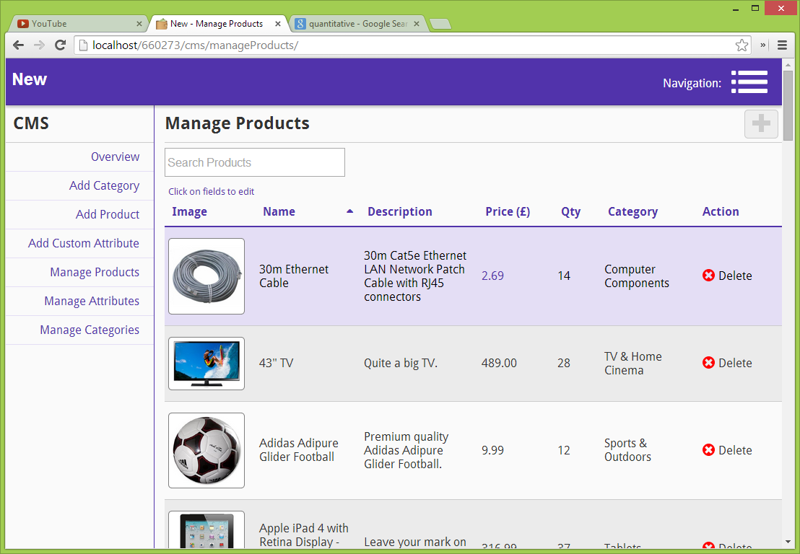

1. To **locate** a record (product, category or attribute):
   1. Use the **ordering** function by clicking on a column name (e.g. Name, Description, Price, etc…) to sort
   2. Use the **search** bar to locate more specific records
2. To **edit** a field:
   1. Click on the field you wish to edit
   2. For most fields you can then just type a new value
      1. It will update automatically with valid input
   3. For the Category field of a product it will display a dropdown box with which you should locate the new category you wish to put the product in

# Managing Orders

1. The admin section of the site (navigate to *siteroot*/admin) displays some summary information of your shop and also provides the ability to manage orders
2. Using either navigation available(left or top right) follow the link to “Order Management”
3. There should be two tables present:
   1. Orders Awaiting Dispatch
   2. Orders Awaiting Delivery
4. When orders have been placed you will see them here.
   1. Click the view link in the record of an order to view the contents (i.e. the products) of the order.
   2. Click the “Mark as dispatched” link to flag the order as dispatched.
   3. Click the “Mark as Delivered” link to flag the order as delivered (i.e. completed).